
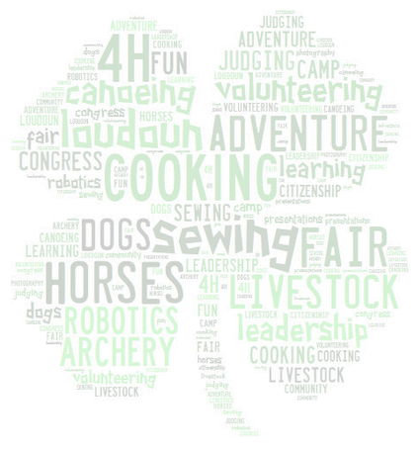

4 - H Agricenter’s
Yearbook

2 0 2 4 - 2 0 2 5

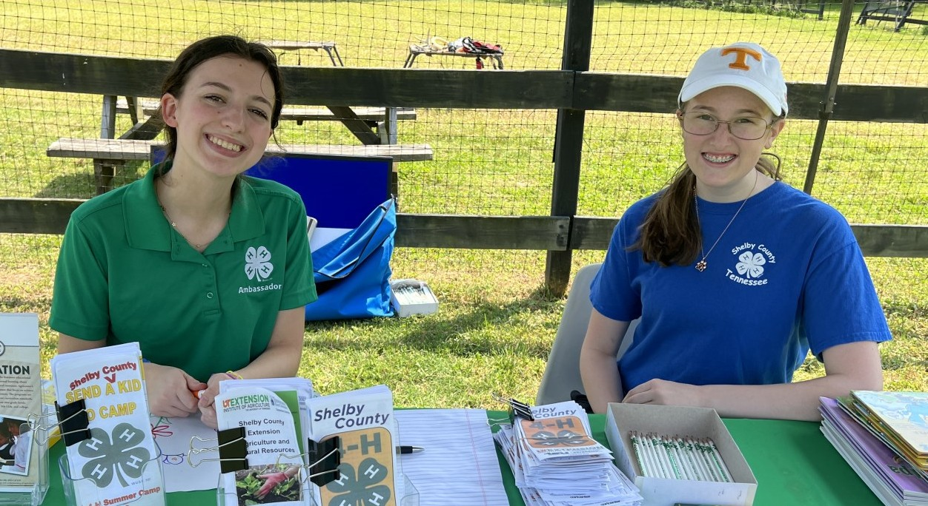


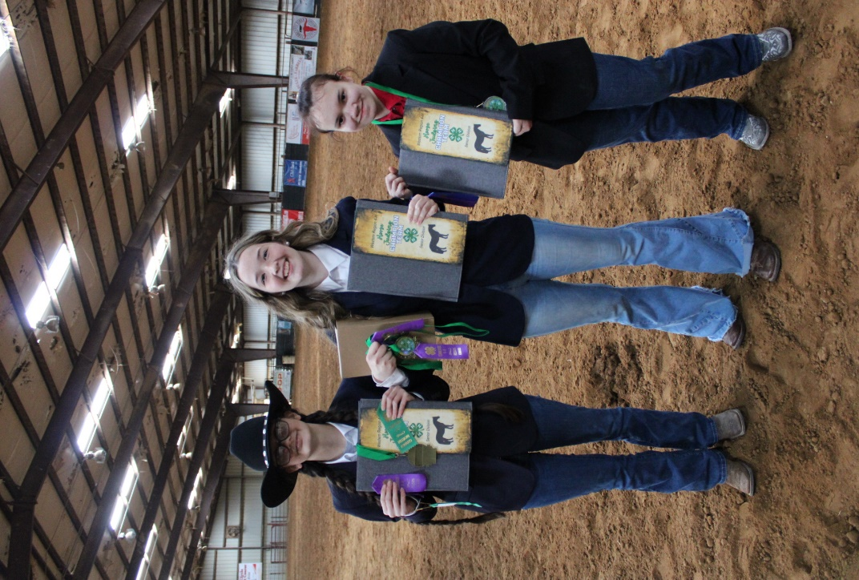

Shelby County 4-H
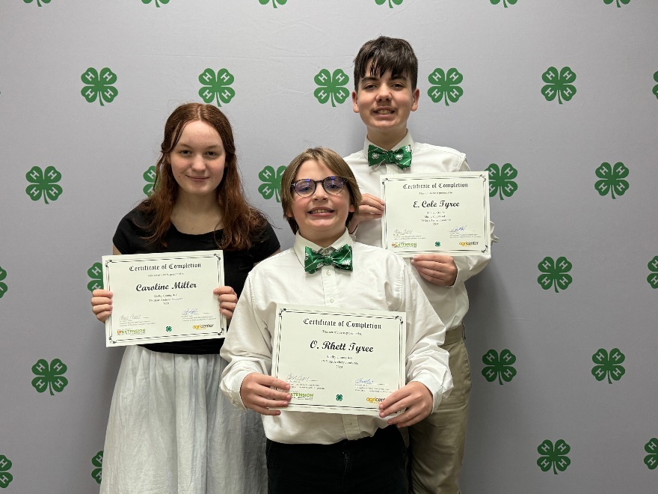
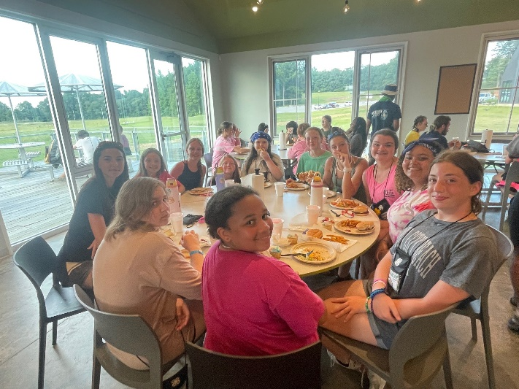
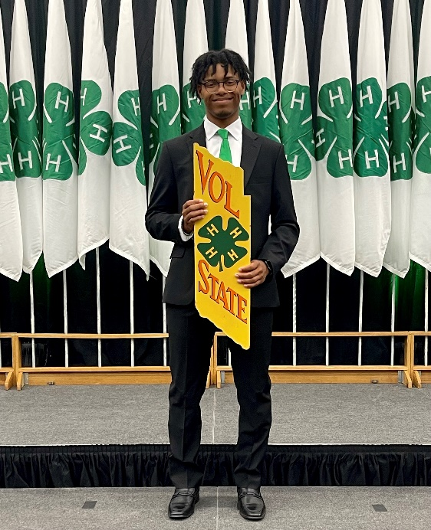
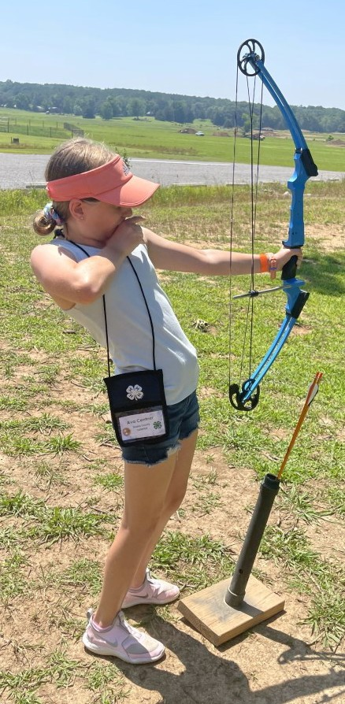






UT-TSU Shelby County Extension Office
7777 Walnut Grove Rd
Suite B, Box 21 Memphis, TN 38120
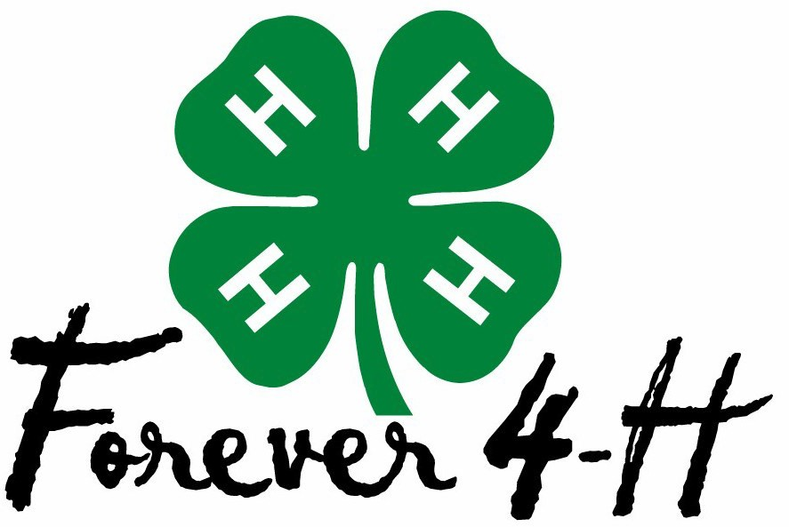

(901) 752-1207

Website: www.shelby.tennessee.edu Facebook: @Shelby4H Instagram: @Shelby4H
Office Hours: 8:00am ~ 4:30pm Monday ~ Friday

Meet the County 4-H Staff:
Tim Roberts ~ AgDirector of Education, tim.roberts@utk.edu
Michael Owen ~ 4-H Agent, mowen@utk.edu
Kelly Ravlija ~ 4-H Agent, krav@utk.edu
Kyla Szemplinksi ~ 4-H Agent, kszempli@utk.edu
Sydney Grayson ~ 4-H Agent, sgrayso6@tnstate.edu

The University of Tennessee Extension offers its programs to all eligible persons regardless of race, color, national origin, sex, age or disability and is an Equal Opportunity Employer.



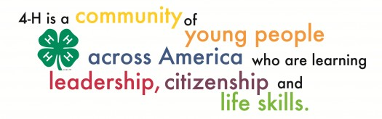
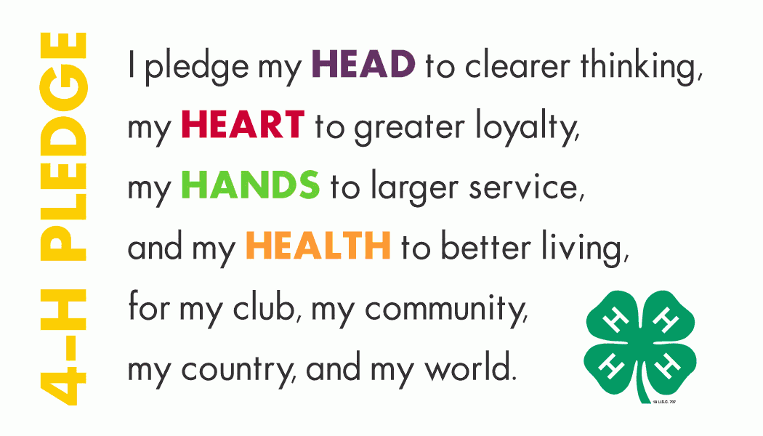

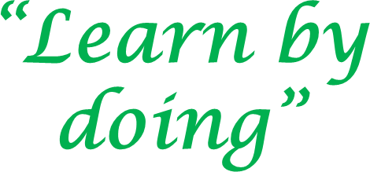
What is 4-H?

The 4-H Pledge:

The 4-H Motto:

The 4-H Slogan:



The Business Meeting
4-H Officer Responsibilities

President
- Lead the group throughout the entire meeting
- Choose volunteers to lead the Pledge of Allegiance and 4-H Pledge
- Keep order in the class
- Be prepared and make sure all officers are ready and prepared

Vice President
- Be in charge of the meeting if the president is absent
- Give the “Thought of the Day”
- Be prepared and work with the president to make the meeting run smoothly

Secretary
- Take accurate minutes (notes) of all aspects of the 4-H meeting. You should write down everything that is discussed while the meeting is taking place, not when you get home. Everything, from the time the meeting begins, until the time the meeting is adjourned, should be documented in the secretary’s book
- Read minutes at the appropriate time during the meeting
- Be prepared with pencil and secretary’s book

Reporter
  - Report on activities going on in school
  - Keep participation chart up to date


4-H Club Meeting Outline
The elected officers are responsible for conducting the business meeting each month. Each officer should follow the outline below. The officer should read the statement printed beside their elected office.

President: “I will now call this meeting to order.”

President: (chose someone to lead us in the Pledge of Allegiance).
For example: “Sally will now lead us in the Pledge of Allegiance”, then say, “Please stand for the American Pledge and remain standing for the 4-H Pledge.”

Vice-President: “I will now read the thought of the day.” [or introduce the name of the person who will be reading].

President: “The secretary will read the minutes from the last meeting.”

Secretary: Read minutes from the secretary’s book.

President: “The reporter will now give the Club report.”

Reporter: Presents report on activities in club and projects.

President: “The reporter will now update the participation chart.”

Reporter: [Update the chart by giving check marks to those 4-H members who have participated in the contest for the month].

President: “If there is no further business, I will end the business part of the meeting and turn the meeting over to our 4-H Agent.”

County Judging & Contest Advancement

County, Sub-Regional, Regional, State & National Levels For Youth in Grades 4, 5, 6, 7, 8, 9, 10, 11 & 12

This Symbol: 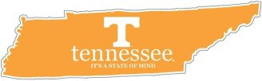, indicates that contest is a prerequisite to more advanced contests.
The following county events serve as qualifiers for competing at higher levels such as Sub-Regional, Regional, State and National level contests. See each contests’ page for more details.
Piggy Bank Pageant: Top 3 county piggy banks advance to the online State Piggy Bank Pageant.
Poster Art Contest: Top 3 county posters advance to the State Competition.
Photography Contest: Top 10 photographs overall from both of the Junior High and Senior High categories combined will advance to the State Competition.

Public Speaking Contest
- Sub-Regional (4th - 8th Grades): All 1st Place winners will have the opportunity to advance to the Sub-Regional Contest which is held in alternating counties.
- Regional (9th - 12th Grades): All 1st Place winners will have the opportunity to advance to the Regional Contest held at the Western Region Office in Jackson, Tenn.
Project Showcase: ALL 4-H’ers who participate in the County Project Showcase Contest are eli- gible to advance to the Regional Project Showcase held at Parkway Middle School in Jackson, Tenn.
Additional Contests and Shows (all 4th grade through 12th grade unless otherwise indicated):
Chick Chain
Consumer Decision Making (CDM) Judging (9th - 12th)
Dairy Judging
Dairy Products Judging (9th - 12th)
Forestry Judging
Geographic Information System (GIS) Mapping Contest Grill Master Challenge (6th - 12th)
Horse Judging
Horse Hippology & Quiz Bowl Horse Shows [Regional & State] Land Judging
Livestock Judging Livestock Shows [Regional & State]
Meat Science Judging Poultry Judging Poultry Quiz Bowl
Shooting Sports Jamborees [Air Rifle, Air Pistol, Archery, BB Gun, Hunting Skills, Shotgun] Skill-a-thon [FCS Skills] (6th - 12th)
Wildlife Judging
For more information on any of these activities and events, please contact Tim, Michael, Kelly, Sydney or Kyla.

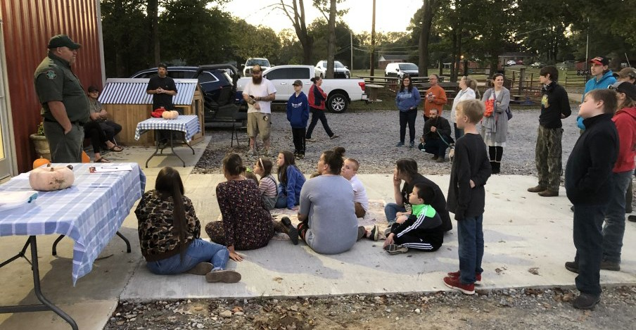

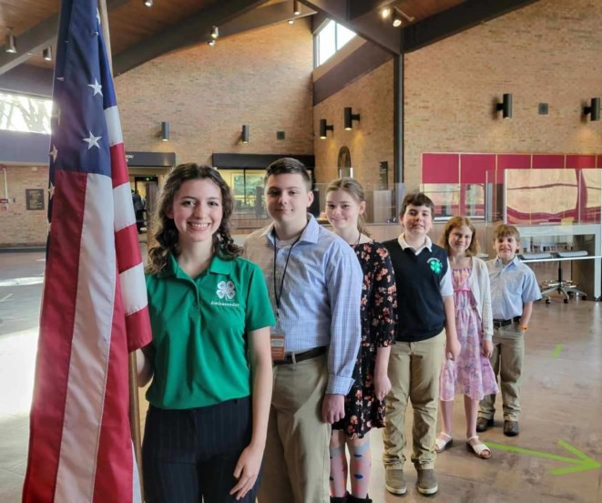
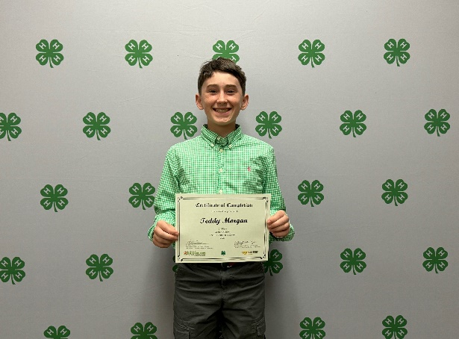
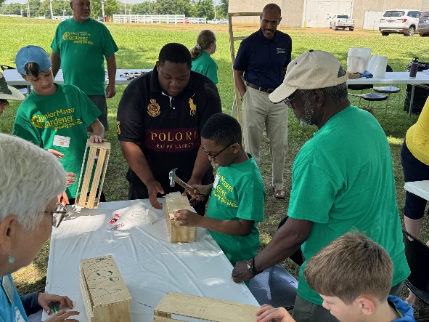
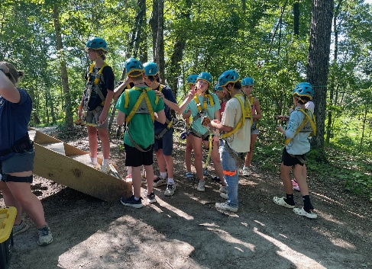
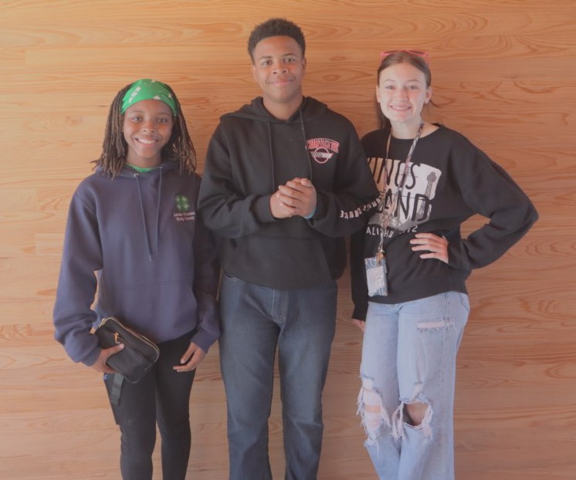
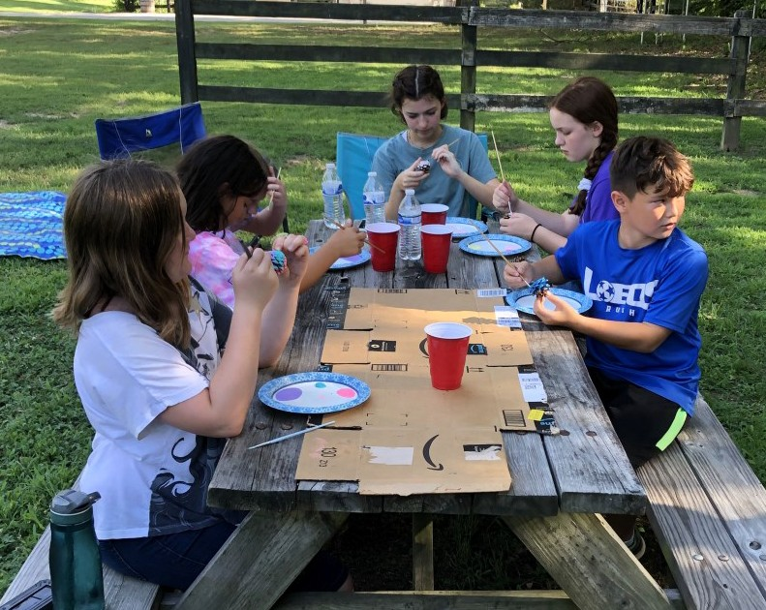
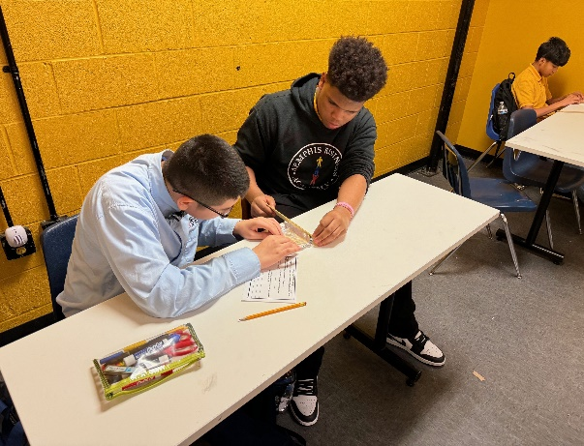
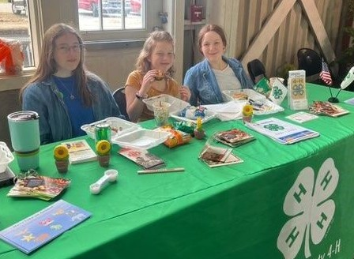
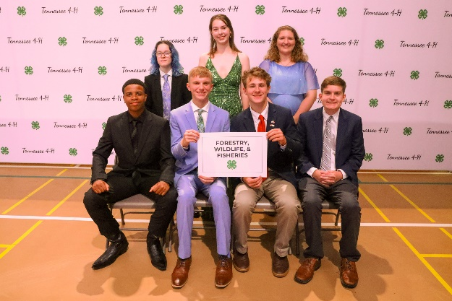
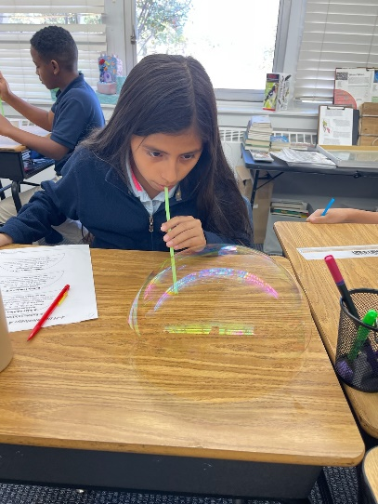
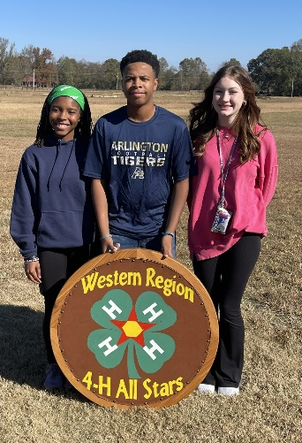
Shelby County 4-H

Junior 4-H’ers Activities / Events

County, Sub-Regional, Regional, State & National Levels For Youth in Grades 4 & 5
For more information on any of these activities and events, please contact Tim, Michael, Kelly, Sydney or Kyla.

Junior Summer Camp @ Lone Oaks Farm (Middleton, May 26 - 30, 2025): Junior 4-H
Camp is a 5-day residential camp available for youth who have completed grades 4 - 6.
Activities include a lake, inflatable slide & obstacle course, fishing, kayaking, paddle board- ing, gaga ball, snack shack, camp-wide games, archery, .22LR rifle, basketball, volleyball, soccer, campfire & s’mores, skits, nature hikes, leatherwork, t-shirt tie-dye, zipline and so much more!

Target S.M.A.R.T. Camp (Crossville, May 26 - 30, 2025): Target SMART Camp is for
4-H’ers enrolled in grades 5 - 12 who are interested in our Shooting Sports Program. Camp offers youth the opportunity to learn appropriate skills to succeed in a variety of shooting sports and related areas such as archery, riflery, shotgunning, muzzle loading and outdoor skills. Programs emphasize safety, correct posture, form and responsible use.

CloverBud Activities / Events

For Youth in Pre-K, Kindergarten and Grades 1, 2 & 3


If you see this: , it indicates all of our opportunities for CloverBuds.

CloverBuds are very special young people indeed! In fact, they are so special, that we’ve created a program just for them! Many of our 4-H Clubs throughout the county offer a special CloverBud Club. Every 4-H Club is unique, so it is safe to assume that every CloverBud Club is just as unique as well. If you are searching for a place for younger siblings to learn and grow, why not consider joining a 4-H Club which also has a CloverBud Club as well!

Here are some of the county activities and events where CloverBuds are welcome to participate and learn:
Poster Art Contest
Photography Contest Piggy Bank Contest
Bread Baking Contest County 4-H Fair

Junior High 4-H’ers Activities / Events

County, Sub-Regional, Regional, State & National Levels For Youth in Grades 6, 7 & 8
For more information on any of these activities and events, please contact Tim, Michael, Kelly, Sydney or Kyla.

Junior Summer Camp @ Lone Oaks Farm (Middleton, May 26 - 30, 2025): Junior 4-H
Camp is a 5-day residential camp available for youth who have completed grades 4 - 6.
Activities include a lake, inflatable slide & obstacle course, fishing, kayaking, paddle boarding, gaga ball, snack shack, camp-wide games, archery, .22LR rifle, basketball, volleyball, soccer, campfire & s’mores, skits, nature hikes, leatherwork, t-shirt tie-dye,
zipline and so much more!
Junior High Adventure Camp @ Lone Oaks Farm (Middleton, June 30 – July 4 and July
14 - 18, 2025): Junior High Adventure Camp is a 4-day residential camp available for youth who have completed grades 7 and 8. Activities include a lake inflatable slide & obstacle course, fishing, kayaking, paddle boarding, gaga ball, snack shack, camp-wide games,
archery, .22LR rifle, basketball, volleyball, soccer, campfire & s’mores, skits, nature hikes, leatherwork, t-shirt tie-dye and so much more!

Academic Conference (Knoxville, June 10 - 13, 2025): Academic Conference is for 4-H’ers who have completed grades 6 - 8 from all across the state to come together in Knoxville and stay in The University of Tennessee’s on-campus dorms just like college kids. While you are there, you will receive specialized instruction and training from college professors, tour parts of campus related to your 4-H Project and get to experience what college is like, from sharing meals in the dining hall to pool parties in the aquatics center. The conference provides a variety of rewarding and fun-filled experiences in the classroom, outdoor and laboratory settings.

State Electric Camp (Knoxville, June 23 – 26, 2025): State Electric Camp is for 4-H’ers
who have completed grades 6 or 7 from across the state who have an interest in energy
ranging anywhere from production to maintenance / repair professionals. You don’t have
to be enrolled in the electric project to attend. 4-H’ers may attend Electric Camp only
once during their 4-H career.
Target S.M.A.R.T. Camp (Crossville, May 26 - 30, 2025): Target SMART Camp is for
4-H’ers enrolled in grades 5 - 12 who are interested in our Shooting Sports Program. Camp
offers youth the opportunity to learn appropriate skills to succeed in a variety of shooting sports and related areas such as archery, riflery, shotgunning, muzzle loading and outdoor skills. Pro- grams emphasize safety, correct posture, form and responsible use.

Honor Club (1st Tuesday / month): This group is designed for youth in grades 6-12 who
wish to participate in service-learning opportunities and build their leadership and citizenship skills. They also help to open the doorway to many regional, state and national events and opportunities through direct contact with the 4-H & Extension office.

Senior High 4-H’ers Activities / Events

County, Sub-Regional, Regional, State & National Levels For Youth in Grades 9, 10, 11 & 12
For more information on any of these activities and events, please contact Tim, Michael, Kelly, Sydney or Kyla.
4-H State Congress (Murfreesboro, March 9 - 12, 2025): State Congress is an invitational event for 4-H’ers in grades 9 - 12 who have been selected as a state finalist after submitting their Leadership or Citizenship portfolio or as a Regional Public Speaking winner. 4-H’ers in grades 9 & 10 may also attend as a Senator or Representative if they are selected after submit- ting an essay on the current year’s Congress theme.

4-H State Roundup & All-Star Conference (UT Knoxville, July 21- 25, 2025): State Roundup is an invitational event where 4-H’ers in grades 9 - 12, who have submitted their project portfolio, have been recognized as a regional winner within their project.

Southern Region Teen Leadership Conference (Crossville, September 19-23, 2025):
SRTLC is for youth who are ages 14 - 18. It is a multi-day, multi-state conference where 4-H teens can come together to share and learn ways to make a positive change and impact all
across the Southern Region. The conference is a terrific networking opportunity!

Target S.M.A.R.T. Camp (Crossville, May 26 - 30, 2025): Target SMART Camp is for 4-H’ers enrolled in grades 5 - 12 who are interested in our Shooting Sports Program. Camp offers youth the opportunity to learn appropriate skills to succeed in a variety of shooting sports and related areas such as archery, riflery, shotgunning, muzzle loading and outdoor skills. Pro-
grams emphasize safety, correct posture, form and responsible use.

Honor Club (1st Tuesday / month): This group are designed for youth in grades 6 - 12 who wish to participate in service-learning opportunities and build their leadership and citizenship skills. They also help to open the doorway to many regional, state and national events and opportuni- ties through direct contact with the 4-H & Extension Office.

State Honor Club: State Honor Club is a continuation of the Honor Club. Once 4-H’ers accumu- late 200 points, they can submit their State Honor Club application to the 4-H Office, and once approved, they will be sent to the state for recognition.

All-Stars: Once an Honor Club member has completed the 8th Grade and has been an active State Honor Club Member for at least one year, they may apply to become an All Star. Other perks include invitations to the annual Spring and Fall All Star retreats throughout the state.

Vol State: Once an active All Star has completed the 10th Grade, they may become an eligible
candidate to receive the Vol State award. Vol State gives deserved recognition to 4-H’ers who have particularly outstanding records in project achievement, leadership and service in 4-H. This is the absolute highest and top honor 4-H’ers are able to receive in Tennessee 4-H.

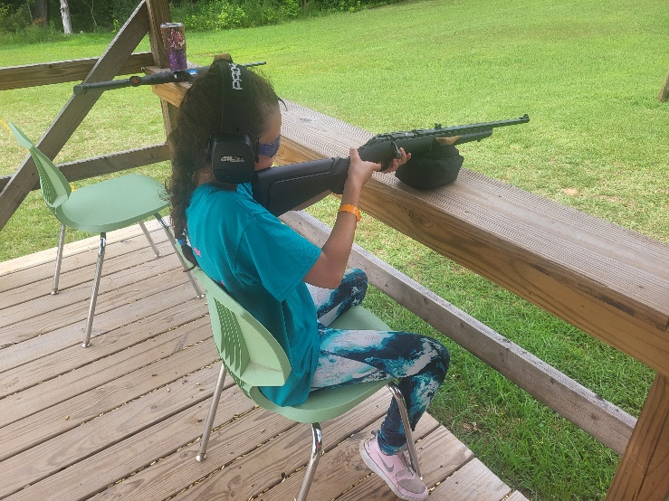

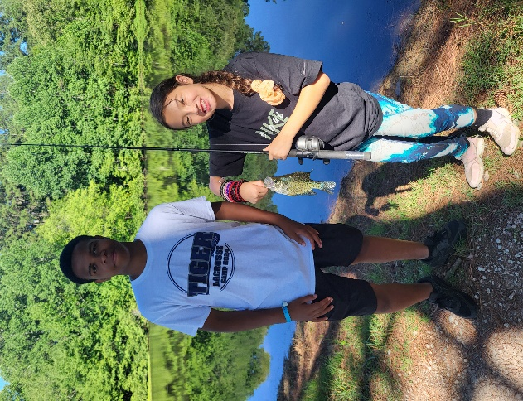
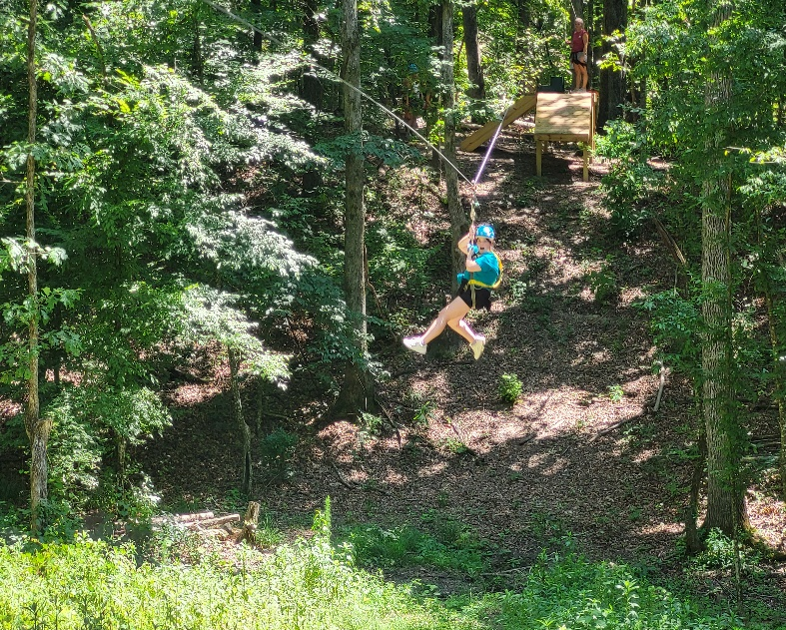
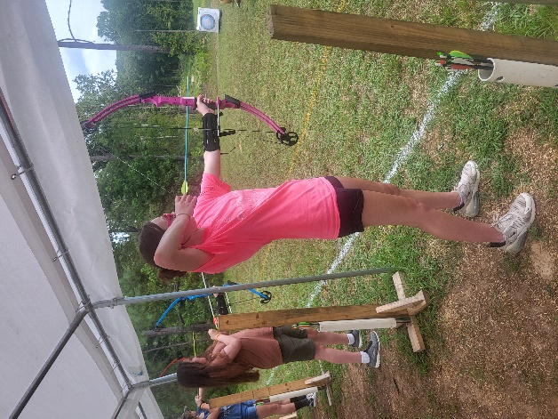
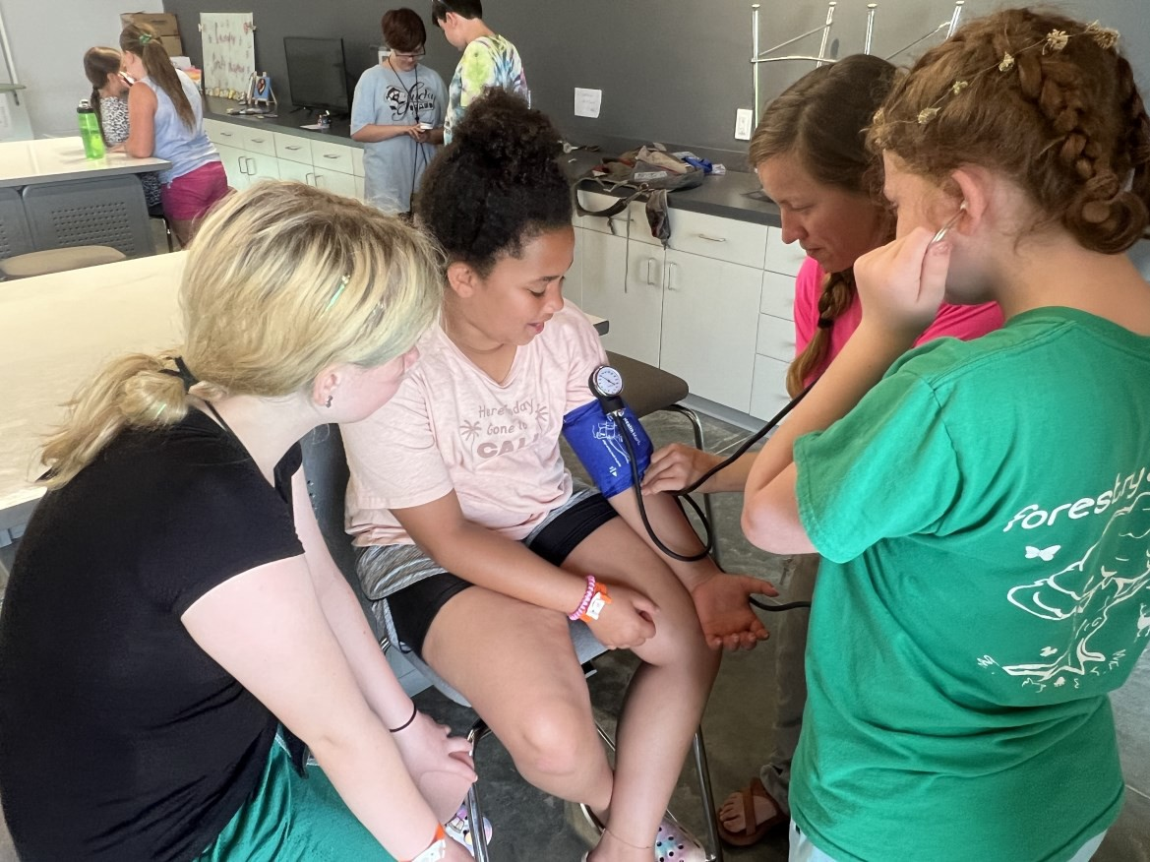

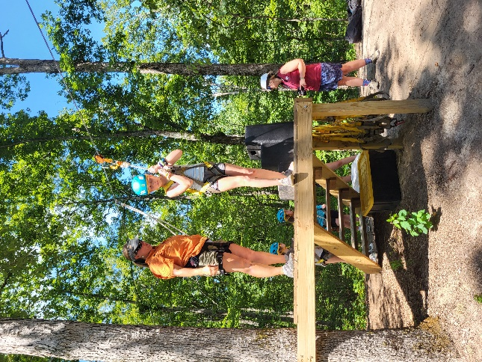

Summer Camp 2024 @ LOF

County Poster Art Contest
Entry Deadline: December 13, 2024 @ 4:30pm
Location: UT-TSU Shelby County Extension Office
ABOUT (For more information, please contact Tim, Michael, Kelly, Sydney or Kyla.)
- 4-H’ers will create a poster which PROMOTES 4-H to others. The “Top 3” posters in the county will advance to the regional competition. Yes, CLOVERBUDS are welcome!
- Digital Marketing Category. The same regular poster contest rules apply and digital entries must be sub- mitted as a PDF file to one of the agents with “Digital Poster Art Contest Entry” as the subject line.

GUIDELINES:
- While brainstorming, imagine signs, billboards and advertisements. Start with a simple, catchy idea and create a slogan for the theme of your poster.
- Use your space wisely. Before marking on your poster board, lightly sketch out designs with a pencil and lay letters down before permanently gluing them so you can adjust your space correctly.
- Any color poster board may be used. Choose colors wisely by using a color wheel to help choose colors which complement each other.
- Simple, block-style letters are easier to read than cursive or script letters. Letters that are cut using a
letter-cutter or cut from construction paper look neater than drawing letters on your board. Make sure letters are large enough that they can be seen from several feet away.

RULES:
- Your poster must promote 4-H and include the 4-H emblem (when using the 4-H emblem on your poster, please
follow criteria specified by the national guidelines regarding use of the 4-H emblem or contact the office).
⇒ Do not obscure or place text & other images (photos, drawings, symbols) over or on top of the 4-H Emblem.
⇒ Use only official colors. The clover stem should turn to the right only and the clover should not be slanted.
- Posters must be 22” x 14” (length x height) horizontal oriented (landscape, 22” left to right, 14” top to bottom).
- 4-H’ers Name, Address, County, Age, Grade & email address should be on the back in the upper right corner.


- The word: “4-H” as well as the 4-H “Clover”  must be included in your poster (See images right below).
4-H
BACK OF POSTER

Horizontal

- Design must be original and relate to the theme.
- Do not use copyrighted material (example: Marvel superheroes, Disney princesses, Lego characters…)
- Do not copy a slogan such as “Beef, It’s What’s for Dinner”, “Just Do It” or “May the Force be with You”.

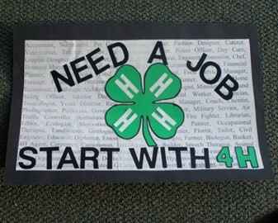
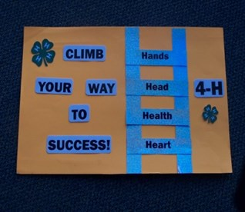
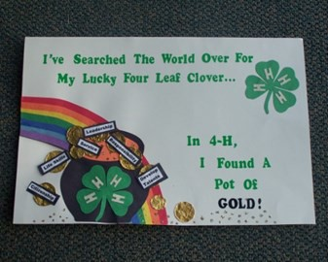

County Public Speaking Contest

Date: January 30, 2025 @ 6:00pm
Location: Agricenter Building “C” (7777 Walnut Grove Rd, Memphis, TN 38120)
ABOUT (For more information, please contact Tim, Michael, Kelly, Sydney or Kyla.)
4-H’ers (Grades 4 - 12) will deliver a timed, prepared speech to a panel of judges. All 1st Place winners will eligible to advance to the Western Regional Competition (Grades 9 - 12) or the Southwest Area Sub-Regional Competition (Grades 4 - 8).
Pre-registration: Call 901-752-1207
Registration: 5:00pm to 5:45pm
Contest Commences: 6:00pm

GUIDELINES:
Speeches are made up of three parts: Introduction, Body, Conclusion
Introduction—start your speech with a question or a catchy phrase, tell your audience what you will be speaking about.
Body—this contains the different points you’d like to talk about. You should include at least 3 points. Conclusion—end your speech with a poem, neat fact, catchy phrase again or a related joke. Don’t forget to remind them of the purpose of your speech’s main topic.

RULES:
4th Grade: 1 ~ 2 minutes
4th—8th Grade: You may choose your own topic. Examples such as: “My favorite .”, “A person you admire.”, “A subject or topic you are learning
about in school.” Note cards may be used, but NO visuals.
5th Grade: 2 ~ 3 minutes
6th Grade: 3 ~ 4 minutes
7th Grade: 4 ~ 5 minutes
8th Grade: 4 ~ 5 minutes

9th Grade: 5 ~ 7 minutes
10th Grade: 5 ~ 7 minutes

11th Grade: 5 ~ 7 minutes
12th Grade: 5 ~ 7 minutes

9th—12th Grade: All speeches must relate in some way to the 4-H member’s
experience in 4-H as well as something learned. It should also promote 4-H.
11th—12th Grade: In addition to the regular 4-H speech, 11th and 12th Grade 4-H’ers will be expected to deliver an extemporaneous or impromptu speech.

Speakers will be expected to dress appropriately.
Girls: suit, dress, nice top, modest skirt or pants, hair should be pulled away from face.
Boys: suit; khaki or dark dress slacks; nice, buttoned, collared shirt (polo or full button-down); tie (optional)
ABSOLUTELY NO: jeans (blue or any color), athletic wear, action wear, t-shirts, hoodies, sweatshirts,
head covering (hats, caps, beanies, doo-rags, bandanas…), shorts or open-toed shoes including flip-flips and sandals.

County Public Speaking Contest (Continued…)

EXPLANATION of Judging Criteria and Points Speaker
Appearance: As the speaker approaches the lectern and throughout the presentation, is their posture good; do they stand solidly on the floor; are their clothes (does not matter whether or not they are new or fashionable) clean and pressed? Does the speaker sway from one foot to another; lean on the lectern or table; slump and show poor
grooming? A perfect score for this category is 10 points.

Language: Is it understandable, pleasing, meaningful, vivid and properly announced with proper grammar? Scores may range from 0 to 20.

Projection / Voice: Do they have eye contact with the audience? Does the presentation have sufficient volume? Is it clear, distinct and presented with expression and enthusiasm? Does the speaker instead present a memorized or read report? Do they com- municate? Scores may range from 0 to 10.

Preparation: Whether or not the speaker occasionally refers to notes, do they seem to be well prepared? Do they read the speech, stumble over words or thoughts, or lack
preparation (whether notes or memory) to carry through the presentation? Scores may vary between 0 and 15.
Subject Matter and Composition
Organization: Do ideas center around a central theme in a logical order, easily followed and understood by listeners? Does the speech seem poorly organized with random ideas or with ideas which do not fit into the theme? Points may range from 0 to 10 here.

Sources: Is the information accurate? Is the topic narrow enough for the message to be given completely? Has the speaker earned the right to speak on the subject through study and experience (preferably in 4-H)? Is the information current? Is the information seem- ingly out-of-date, too broad to be covered completely or incorrect? From 0 to 10 points
are possible here.

Introduction, Summary and Conclusion: Does the introduction catch the interest of the audience while presenting the theme for the entire speech? Speakers should NOT begin by giving their name and club or by recognizing the “honorable judges, ladies and gen- tlemen, etc.” Does the summary tie the important points of the speech to the theme in an interesting way that makes you remember the speech? Does the speech have no real in- troduction or perhaps an inadequate introduction or summary? Points will vary from 0 to 10 in this category with half the scoring for the introduction and half for the summary.

Time Penalties: 5 points will be deducted for being under the minimum time. 1 point will be deducted for every 30 seconds a speech exceeds the maximum time limit.

Tie-Breaker: To break a tie use, the “Use of Language” score from the score card will be used.

County Photography Contest
Entry Deadline: February 21, 2025 @ 4:30pm
Location: UT-TSU Shelby County Extension Office
ABOUT (For more information, please contact Tim, Michael, Kelly, Sydney or Kyla.)
4-H’ers will submit photographs in 6 categories to be judged by a panel of judges. Yes, CLOVERBUDS
are welcome!

GUIDELINES:
If you print your photos at home, be sure to use a high-quality photo paper.
Photos may be in color, black & white (B&W) and sepia. Grading of the photos will be conducted by a panel of judges.
Photos will be judged based upon the subject or content, exposure and clarity of the photo.

RULES:
You may use any type of camera you’d like, but digital cameras or cellphones / tablets are often easier and more convenient to use.
Maximum photo size should not exceed 5” x 7”.
Every photo entry must have a completed entry form filled out and TAPED to the back of each photo. Do
NOT use glue to attach photo entry forms.
Only ONE entry per category is allowed, however, you may enter all 6 categories. Entries may be comprised of a SINGLE entry or a SERIES.
A series must consist of 4 photos showing a “before and after” or a “how-to” theme.
A series entry must have the 4 photos numbered sequentially or in order of events in addition to entry forms on each photo in the series.
Place all entries from an individual 4-H’er in one envelope with NAME, ADDRESS, CITY, STATE, ZIP CODE, GRADE, SCHOOL / CLUB NAME and TEACHER / LEADER NAME.

Categories:
1. People 2. Buildings 3. Animals 4. Landscape 5. Citizenship 6. Leadership

STATE PHOTO SEARCH CONTEST:
Grades 7 - 12: The top 10 photos will be mailed to the State Office in Knoxville and entered into the Ten- nessee 4-H State Photo Search Contest. These photos MUST relate to 4-H in some way in order to be eligi- ble for the State Photo Search Contest.

County Piggy Bank Contest
Entry Deadline: March 28, 2025 @ 4:30pm
Location: UT-TSU Shelby County Extension Office
ABOUT (For more information, please contact Tim, Michael, Kelly, Sydney or Kyla.)
4-H’ers will create and submit their very own Piggy Bank to help promote the importance of financial edu- cation and being prepared for the future. Yes, CLOVERBUDS are welcome!

GUIDELINES:
Create a Piggy Bank that is unique and has personality. Give your Piggy Bank a theme! It can reflect your own personality.
Your Piggy Bank does not have to be a traditional pig; it can be ANYTHING, such as a princess pig, clock, barn, camo.
You may construct your piggy bank from items such as paper, milk cartons, coffee cans and just about an- ything that will help make your Piggy Bank unique. You may decorate your Piggy Bank with paint, se- quins, glitter and anything that will help its uniqueness.
Be sure your Piggy Bank is able to be transported without falling apart; nothing fragile.

RULES:
Piggy Banks must be NO larger than 12” x 12” x “12”.
Piggy Banks must NOT be created with or include GLASS.
Piggy Banks should be made to be travelable and portable, again, nothing fragile or anything that could fall apart.
Do not turn your Piggy Bank in with money or currency in it.
The Piggy Bank Entry Form must be taped to the BOTTOM of your Piggy Bank. Entry forms are found in the back of this yearbook.

STATE PIGGY BANK PAGEANT:
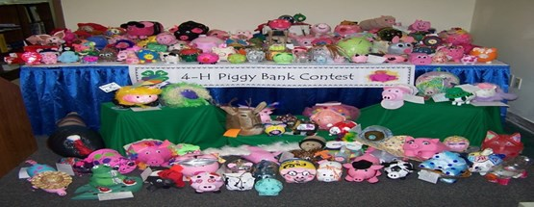
All 1st Place winners in each grade level will be entered into the State Piggy Bank Pageant. This contest is different than the local county contest. Piggy Banks must be received into the Extension Office by the regular county deadline.

Grade Level breakdown: CloverBuds
Kindergarten & 1st Grades
2nd & 3rd Grades 4th Grade
5th Grade
6th, 7th & 8th Grades
9th, 10th, 11th & 12th Grades

County Project Showcase Contest

Date: April 10, 2025 @ 6:00pm
Location: Agricenter Building “C” (7777 Walnut Grove Rd, Memphis, TN 38120)
ABOUT (For more information, please contact Tim, Michael, Kelly, Sydney or Kyla.)
4-H’ers (Grades 4 - 12) will have the opportunity to demonstrate something they have learned in their 4-H project within the last year.
Pre-Registration: Call 901-752-1207
Registration: 5:00pm to 5:45pm
Contest Commences: 6:00pm

GUIDELINES:
Project Showcase is similar to the Public Speaking Contest, but you may have a VISIAL AID!!!
You may use a tri-fold display board, just as you would in a school science fair.

RULES:
Time: 2-3 minutes. Project Demonstration. You should be able to show how your project works
“step-by-step” to a panel of judges. You must setup and breakdown in a room with an audience.
4th Grade:
5th Grade:

6th Grade:
Time: 2-3 minutes. Interactive Table-Top Display Exhibit. You should be prepared to explain your project to the judges.
SPECIAL EXTRA CATEGORY: You may enter your record-book / portfolio to be judged separately
from your table-top display. For more info, please refer to: https://4h.tennessee.edu/Pages/forms_materials.aspx
7th Grade:
8th Grade:

9th Grade:
Interview with a panel of judges. A visual is allowed. You will have 2-3 minutes to explain your visual.
10th Grade:

11th Grade:
Interview with a panel of judges. In addition to the visual, 4-H’ers will also submit a working resume
12th Grade:

Participants will be expected to dress appropriately.
Girls: suit, dress, nice top, modest skirt or pants, hair should be pulled away from face.
Boys: suit; khaki or dark dress slacks; nice, buttoned, collared shirt (polo or full button-down); tie (optional)

ABSOLUTELY NO: jeans (blue or any color), athletic wear, action wear, t-shirts, hoodies, sweatshirts, head covering (hats, caps, beanies, doo-rags, bandanas…), shorts, flip-flips, sandals, open toe shoes.

County Project Showcase Contest (Continued 2…)

Explanation
Demonstrator (15 Points possible)
Appearance: Neat / clean. Posture. No distracting jewelry. Hair out of eyes. No gum. Well-groomed. (5 Points)
Voice: Is it pleasing, clear and distinct with correct grammar? (5 Points)
Poise and enthusiasm: Good voice projection. Good eye-contact with the audience and judges. Smiles.
Appears calm and collected. (5 Points)
Presentation (50 Points possible)
Introduction: Is it attention-getting, giving the purpose of the demonstration; brief and important;
telling what is to be done; or is it just the opposite, merely repetition of the demonstrator’s name
and club when he/she has already been introduced? (10 Points)
Main points clearly stated: Are all the steps clearly seen and can be understood by the audience? Are the points easily distinguished? (10 Points)
Summary: Is it interesting and short, but complete; key points re-emphasized; no new material introduced; purpose met? If gestures are used, are they natural? (10 Points)
Demonstration given convincingly: Does it seem the 4-H’er has knowledge of the subject and does not read his/her information? (5 Points)
Equipment / Visuals: Is it well-selected and organized; work area clearly seen; suitable and effective equipment for the job; equipment handled with ease; arranged for efficient use; used as needed;
without name brands or labels? Are they neat, clear, well-illustrated; used to amplify, not duplicate methods shown; charts not too crowded; simple designs; only needed charts used; charts handled
smoothly? (10 Points)
Work area: Is it left neat or as it was before the demonstration? (5 Points)
Subject Matter (35 Points possible)
Selection and organization: Is it presented in logical sequence with only one theme or idea presented; subject narrow enough to be covered adequately? Is topic related to the 4-H project? (10 Points)
Source of information: Is it accurate and up-to-date; selected from reliable information from USDA or UT Extension recommended practices; personal experience can be cited; source of information can be cited; suited to age, interest and experience of the demonstrator? (15 Points)
Practical questions: Are they answered accurately; 4-H’er admits not knowing answer instead of
guessing; subject adequately covered enough there is no need for additional questions? (10 Points)

Tips for Planning Your Project Showcase
***Be sure to choose a topic that interests you.

Colors  Dark backgrounds, yellow letters are easy to read. White backgrounds with dark letters are attractive. Avoid using bright background with bright letters. Choose colors that are easy to read. | Visual Aids  Visual aids are an important part of the demonstration. Special attention should be given to each visual.  List everything you need for your demonstration. List each step. Briefly summarize your conclusions.
Organization  Begin with an introduction. Discuss main points & objectives.  Summarize your main points in your conclusion. Explain each step. | Writing  Use large lettering you can see from the back row. Block letters are easier to read than cursive.  Capitalize only when necessary.
County Project Showcase Contest (Continued 3…)

Project Areas:

Animal Science – Large Animal
Beef
Horse
Sheep
Swine
Goat
Dairy
*No Live Animals

Animal Science – Small Animal
Companion Animals
Poultry
Veterinary Science (small or large)
*No Live Animals

Consumer Skills
Consumer Ed./Economics
Creative Arts and Design
Photography
Clothing & Textiles
Entrepreneurship

STEM

Computer & Technology
Applied Sciences

Electric

Engineering & Safety Sciences

Environmental Education

Entomology/Beekeeping

Horticulture & Gardening

Plant Science

Forestry, Wildlife & Fisheries

Nutrition/Health

Food Sciences

Nutrition, Health, & Fitness

Personal Growth

Citizenship

Leadership

Communication/Public Speaking

Performing Arts

Recreation

Personal Development

All County Project Showcase Participants will automatically qualify to advance to the Western Region 4-H
Project Showcase.

County Bread Baking Contest
Date: April 25, 2024 @ 6:00pm
Location: Agricenter Building “C” (7777 Walnut Grove Rd, Memphis, TN 38120)
ABOUT (For more information, please contact Tim, Michael Kelly, Sydney or Kyla.)
4-H’ers will have the opportunity to enter a specific type of bread which is different according to their grade level. Yes, CLOVERBUDS are welcome!
Registration: 5:00pm
Contest Commences: 6:00pm

GUIDELINES:
You may use a family recipe or recipe you might find in the paper, a cookbook, a magazine or the Internet. You may have adult help, but adults should not make your bread for you. This is designed for you to learn.

RULES:
*****You MUST make the type of bread assigned specifically to your grade level BEFORE you will be allowed to enter the Favorite Bread / Dessert Contest.***** All bread entries must be placed on a plate covered in foil, clear plastic or a decorative plate.
On the bottom of your bread entry, you must include your NAME, GRADE, CLUB / SCHOOL NAME and LEADER / TEACHER NAME.

Cloverbuds 4th Grade
CloverBuds & 4th Grade: 3 Plain Cornmeal Muffins.
5th Grade 6th Grade
5th Grade & 6th Grade: 3 Plain Biscuits - NO fillings or other flavors allowed.
7th Grade 8th Grade
7th Grade & 8th Grade: Whole loaf of quick bread.
9th Grade 10th Grade 11th Grade 12th Grade
9th, 10th, 11th & 12th Grade: Whole loaf of yeast bread.

FAVORITE BREAD / DESSERT CONTEST:
*****You MUST make the type of bread assigned specifically to your grade level BEFORE you will be allowed to enter the Favorite Bread / Dessert Contest.***** Once you have completed your grade level bread entry, you will be allowed to enter the
“Favorite Bread / Dessert” category. You may enter any recipe of your choosing under this category.

Shelby Co. 4-H County Fair

Date: August 14, 2025 @ 6:00pm
Location: Agricenter Dome Rm. C (7777 Walnut Grove Rd, Memphis, TN 38120)
ABOUT (For more information, please contact Tim, Michael, Kelly, Sydney or Kyla.)

*ALL ENTRIES MUST BE PRE-REGISTERED by Friday, August 8, 2025 @ 4:30pm!!!*
4-H’ers will have the opportunity to show off their creativity by participating in the following categories.
Items eligible must have been made during the 4-H year. Please see the Fair Catalog for more information on deadlines, class breakdown and details, and entry forms. Yes, CLOVERBUDS are welcome!
Check-In: 4:30pm to 5:45pm Judging Commences: 6:00pm

GUIDELINES:

4-H’ers are encouraged to participate in the local 4-H County Fair by entering quality projects,
goods and items made by the 4-H’ers throughout the program year.

Top winners will be awarded premiums based upon the quality of their items and their ribbon assignment.
Categories include, but aren’t limited to:
Arts & Crafts | Recycled Crafts
Horticulture | Poster Art Exhibit
Culinary | Food Preservation
Plant Science | Clothing
Home Grounds  Bread Baking | Pet Show

RULES:

*ALL ENTRIES MUST BE PRE-REGISTERED by Friday, August 9, 2024 @ 4:30pm!!!*

They may be mailed, e-mailed, faxed or brought in person to the Extension Office before the close of business, 4:30pm.
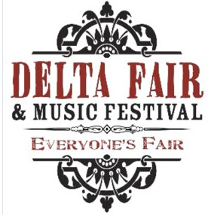
Please refer to the Shelby County 4-H County Fair Catalog for information pertaining to classes, deadlines and entry forms.

***Most County 4-H Fair entries will qualify to be entered into the Delta Fair Youth Categories.***

Shelby County 4-H Clubs

A current directory of our community and school clubs.
For more information on any club, contact Tim, Michael, Kelly, Sydney or Kyla.

Air Rifle / BB Project Group [ Shooting Sports ]: Youth must be both in at least the 4th grade and 10 years old or older. They meet on the 2nd and 4th Tuesday afternoons of each month at Memphis Sport Shooting Association (MSSA) in Arlington. For more information, please contact Michael Owen,
mowen@utk.edu.

Archery Project Group [ Shooting Sports ]: Youth must be both in at least the 4th grade and 10 years old or older. They meet on the 3rd Thursday afternoon of each month at the Bobby Lanier Farm Park in Germantown. For more information, please contact Michael Owen, mowen@utk.edu.

Bartlett 4-H Club [ Forestry / Wildlife ]: Any 4-H youth interested in forestry, wildlife and the general outdoors are welcome. Focus is on preparing for our forestry and wildlife contests. They meet on Monday evenings twice a month at Faith Baptist Church in Bartlett. For more information, please contact
Weida Ringley, weidaringley@gmail.com.

County Sewing 4-H Club [ Textile Science ]: Sewing is open to all youth in 4th grade and up. They meet on the 1st Thursday afternoon of each month at the Bobby Lanier Farm Park in Germantown. For more information, please contact Michael Owen, mowen@utk.edu.
Germantown Library 4-H Club: Provides general 4-H programs and activities. They meet on the 2nd
Monday at5:00 P.M. for more information contact Anne Howard, anne.howard@aveninsights.com.

Germantown 4-H Club: Provides general 4-H programs and activities. They meet on the 3rd Thursday
evening of each month at the Bobby Lanier Farm Park in Germantown. For more information, please con- tact Susan Tyree, susan.gold2@gmail.com.
Honor Club: The Honor Club is open to all youth currently in grades 6 - 12. Emphasis is centered around service-learning opportunities and building leadership & citizenship skills. They meet on the 1st Tuesday evening of each month at the Agricenter. For more information, please contact Kelly Ravlija, krav@utk.edu.

Woodstock Ghost Riders 4-H Club [ Horse ]: Any youth interested in all things horse and equine are welcome to participate, horse ownership is not required. They meet on Sunday afternoons twice a month at the Woodstock-Cuba Saddle Club in Millington. For more information, please contact Kyla Szempliski, kszempli@utk.edu.
In-School 4-H Clubs: 4-H is visible in many schools across Shelby County! If you are interested in getting 4-H Club started at your school or unsure if your school offers 4-H, please contact UT Extension Shelby County at 901-752-1207. Monday - Friday 8:00am - 4:30pm.

Chick Chain, Consumer Decision Making (CDM) Judging, Dairy Products Judging, FCS
Skillathon, Forestry Judging, Land Judging, Life Skills, Livestock Judging, Meats Judging, Poultry Judging and Wildlife Judging please call 901-752-1207.

Regional & State Activities & Events
All dates and locations are TBD and TENTATIVELY set. Please contact Tim, Kelly, Kyla, Sydney or Michael for the most up-to-date information.

Event/Activity | Date | Location
WR Junior Market Swine Show | January 6 | UT Martin or Obion Co. Fairgrounds
State Junior Market Hog Show | January 8 - 11 | Hyder-Burk Pavilion, Cookeville
WR 4-H Hippology & Horse Bowl | January 18 | WTREC, Jackson
Senior Citizenship & Leadership Portfolios Due | January 20 | Submitted Online
State 4-H Congress Registration & Essays Due | January 15 | Shelby Co. 4-H Office
All Star High Council | January 24 - 25 | Lebanon
TSU 4-H Minority Scholarship Applications Due | January 24 | Submitted Online (TSU)
WR Steer Tagging Day | February 8 | Henry Co. Fairgrounds
WR 4-H Public Speaking Contest | February 4 | WTREC, Jackson
State 4-H Livestock Quiz Bowl Contest | February 8 | Murfreesboro
WR 4-H Meats Judging Contest | February 13 | WTREC, Jackson
State 4-H Hippology & Horse Bowl | February 14 - 15 | Brehm Hall, UT Knoxville
WR 4-H Congress Readiness Day & History Bowl | February 22 | WTREC, Jackson
State Council Meeting | Feb. 28 – March 1 | Lebanon
State 4-H Congress | March 9 - 12 | Murfreesboro / Nashville
4-H Beekeeping Essays Due | March 15 | State 4-H Office
WR 4-H All Star Spring Retreat | March 28 - 29 | TBA
Academic Conference Registration & Assistant Applications Due | April 1 | Shelby Co. 4-H Office
4-H WR Project Showcase e-Portfolios Posting Deadline | April 1 | Submitted Online
State 4-H Air Rifle, Air Pistol & BB Gun Jamboree | March 21 - 22 | Rutherford Co. Ext. Office, Murfreesboro
State 4-H Archery Jamboree | April 11 - 12 | Hyder-Burk Pavilion, Cookeville
WR 4-H Horse Judging Contest | April 10 | Triple P Arena, Decaturville
WR 4-H Project Showcase | April 19 | Parkway Middle School, Jackson
State TN 4-H College Scholarship Applications Due | May 1 | Submitted Online
WR 4-H Poultry Judging Contest | April 29 | WTREC, Jackson
State 4-H Shotgun Jamboree | May 3 | Nashville Gun Club, Nashville
Senior 4-H Project e-Portfolios Due | May 1 | Submitted Online
State 4-H Project e-Portfolios Judging | May | Judging performed online
WR 4-H Wildlife Judging Contest | May 14 | Lone Oaks, Middleton
State 4-H Sheep Conference | TBD | Hyder-Burk Pavilion, Cookeville
4-H Target SMART Camp | May 26 - 30 | Clyde York 4-H Center, Crossville
OWLS Conference | May 27 - 30 | “Land Between the Lakes”, Brandon Springs
State 4-H Livestock & Meats Judging Contest | June 3 | Brehm Hall, UT Knoxville
State 4-H Wildlife Judging Contest | June 5 | TBA
WR 4-H Horse Show | June 6 - 7 | West TN Ag Pavilion, UT Martin
Junior High Academic Conference | June 10 - 13 | UT Knoxville
WR Junior Beef Expo | June 14 | West TN Ag Pavilion, UT Martin

Regional & State Activities & Events
All dates and locations are TBD and TENTATIVELY set. Please contact Tim, Kelly, Kyla, Sydney or Michael for the most up-to-date information.

Event/Activity | Date | Location
State Horse Judging, Communications Contest & Demos | June 16 | Shelbyville
State Horse Show | June 16 - 20 | Shelbyville
State 4-H Council Meeting | June 20 - 22 | TBA
State 4-H Electric Camp | June 23 - 26 | UT Knoxville
State Junior Beef Expo | July 9 - 12 | Wilson Co Fairgrounds, Lebanon
WR Roundup Readiness Day | June 28 | WTREC, Jackson
WR 4-H Line & Design Camp | July 7 - 9 | UT Martin
WR 4-H “Rock the Runway” Fashion Revue | July 9 | UT Martin
WR 4-H Culinary U Camp | July 9 - 11 | UT Martin
4-HRoundup & All Star Conference | July 21 - 25 | UT Knoxville
WR Junior Dairy Show | August 11 | Henry Co Fairgrounds, Paris
State 4-H Dairy Judging Contest | August 14 | Lebanon
State Meat Goat Show | August 16 | Wilson Co Fairgrounds, Lebanon
WR 4-H Judging Day (CDM & Skillathon) | August 23 | WTREC, Jackson
WR 4-H Grill Master Challenge | September 6 | TBD
WR 4-H Forestry Judging | September 3 | Lone Oaks Farm, Middleton
State 4-H Council Meeting | September 12 - 14 | Clyde York 4-H Center, Crossville
State Shooting Sports Invitational | September TBD | TBD
WR Junior Sheep Expo | September 13 | West TN Ag Pavilion, UT Martin
WR Junior Goat Show | September 13 | West TN Ag Pavilion, UT Martin
Southern Region Teen Leadership Conference (SRTLC) | September 19 - 23 | Clyde York 4-H Center, Crossville
WR Land Judging Contest | September 25 | Ames Plantation, Hardeman Co.
National 4-H Week | October 5 - 11
State Junior Dairy Show | October 10 - 11 | Lebanon
State 4-H Land Judging Contest | October 13 | TBA
State Junior Sheep Expo | October 24 - 25 | Hyder-Burk Pavilion, Cookeville
WR 4-H All Star Fall Retreat | November | TBA
WR 4-H Livestock Judging Contest | November 13 | Triple P Arena, Decaturville
National 4-H Congress | Nov 28 - Dec 2 | Atlanta, Ga.

County Photography Contest
Entry Deadline: February 21, 2025 @ 4:30pm
Location: UT-TSU Shelby County Extension Office

Entry Forms (Make copies as needed)

Name: Address: City: State: Zip: School / Club: Grade Teacher / Leader: Category: | Name: Address: City: State: Zip: School / Club: Grade Teacher / Leader: Category:
Name: Address: City: State: Zip: School / Club: Grade Teacher / Leader: Category: | Name: Address: City: State: Zip: School / Club: Grade Teacher / Leader: Category:
Name: Address: City: State: Zip: School / Club: Grade Teacher / Leader: Category: | Name: Address: City: State: Zip: School / Club: Grade Teacher / Leader: Category:

Piggy Bank Entry Forms
Entry Deadline: March 28, 2025 @ 4:30pm
Location: UT-TSU Shelby County Extension Office

Entry Forms (Make copies as needed)

Theme: Name: Grade:  School / Club: Teacher / Leader: WHY SAVE MONEY: | Theme: Name: Grade:  School / Club: Teacher / Leader: WHY SAVE MONEY:
Theme: | Theme:
Name: | Name:
Grade: | Grade:
School / Club: | School / Club:
Teacher / Leader: | Teacher / Leader:
WHY SAVE MONEY: | WHY SAVE MONEY:

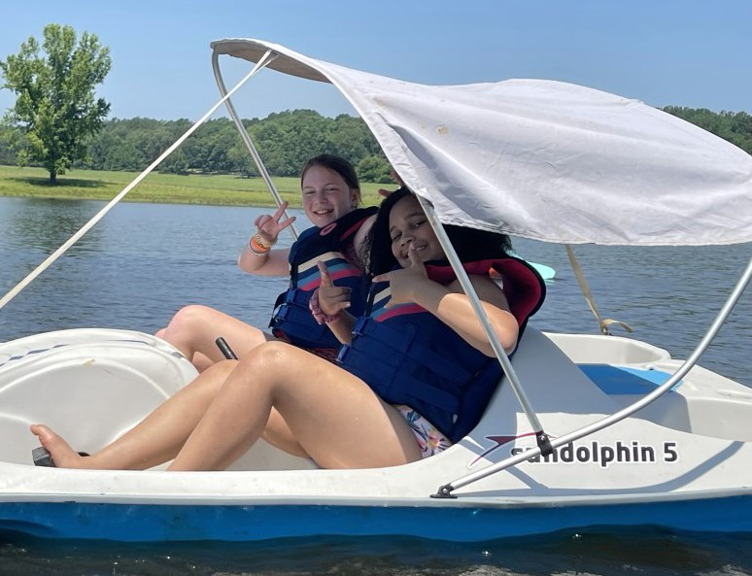


Shelby County 4-H

